MGMS – Human Resource

Functional Specification Document

Ver. 1.4

Version History
Version # | Date | Description
1.0 | 13-Nov-2010 | First Draft
1.1 | 23-Nov-2010 | Added mandatory check error messages

Table of Contents

Version History 2
1 Introduction 4
1.1 Purpose 4
1.2 Scope 4
1.3 Assumptions 4
1.4 Constraints 4
2 HR Management 4
2.1 Current Projects 5
2.2 Project Employees 5
2.3 Project Employee Qualification 7
2.4 Project Employee Experience 9
2.5 Project Employee Salary 11
3 Business Rules 13
4 Status Messages 13

Introduction

Purpose

This document provides the requirements and functional specifications for the Human Resource management Multisite Grant Management System project.
This is not a project plan or a design document. It is a guide for system architecture and development, not for phasing, timelines or deliverables.
Finally, this is a ‘living document’ and the specification will change, continuously, as the project proceeds. More details will be added and the existing information edited as the requirements, scenarios and use cases evolve in the course of the project.

Scope

Currently a single user cannot use the same access for multiple institutions. He will have to use separate usernames and passwords to log into each of the institutions.
Currently the user profiles have not been linked to the employee profiles for each of the institutions.
Currently, the role once assigned to a user, cannot be modified and only a single role can be taken by a user.

Assumptions

The users are unique to the institutions i.e. a user does not belong to more than one institution.
The users of this application are not regular employees of the respective institutions. Currently the employees do not have access to the application.

Constraints
Requirements clarification needed (and awaited for) as to the relationship between users and employees. Clarification is required also for the users and employees’ association with individual or multiple projects, institutions etc.

HR Management

In HR module, there is provision to add personnel against each project.
The details saved are:
  - Details such employee name, employee no:, DOB, joining date, relieving date from the project) , designation etc.
  - Qualification details such as University, exam passed, % marks, passing out year etc.
  - Experience Details such previous employer’s name, joining/relieving dates and designation while there.
  - Salary Details such as salary component, corresponding amount , date with effect from etc

Clicking on the HR Management menu on the left panel will open the Current Projects list screen, as shown below:

Current Projects

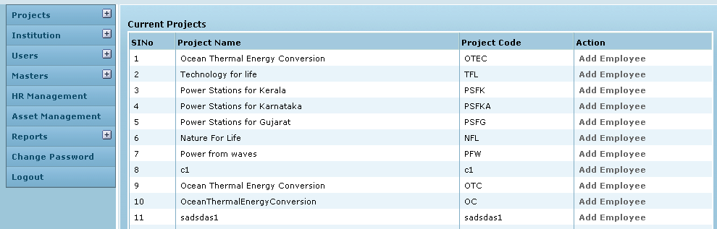

Control Description

Field /Label | Input-Control | Data Type
Sl No | Auto generated sequential numbering for each row
Project Name | Auto populated | String
Project Code | Auto populated | String
Action | “Add Employee” link | link

Clicking on Add Employee for a particular project will open the Project Employees screen as shown below:

Project Employees

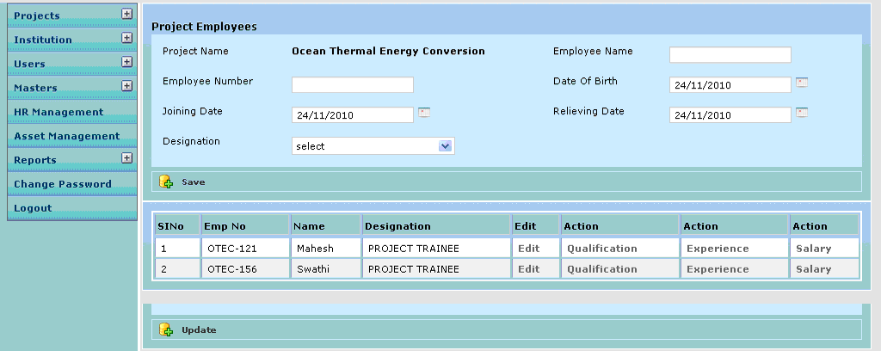

Control Description

Field /Label | Input-Control | Data Type | Remarks / Edit Check
Project Name | Auto populated | String
Employee Name | Textbox | String | Required
Employee Number | Textbox | String | Required; Check for duplicates
Date of Birth | Calendar | Date | Required
Joining Date | Calendar | Date | Required
Relieving Date | Calendar | Date | Optional
Designation | Listbox | String | Required;
Save | Button
Sl.No | Auto incremented sequential | String
Emp No | Auto populated | String
Name | Auto populated | String
Designation | Auto populated | String
Edit | “Edit” | Link | opens the Edit Project Employee screen
Action | “Qualification” | Link | opens the Project Employee Qualification screen
Action | “Experience” | Link | opens the Project Employee Experience screen
Action | “Salary” | Link | opens the Project Employee Salary screen

Clicking on Edit for a particular employee in the table will open the Edit Project Employee screen as shown below:

Edit Project Employee

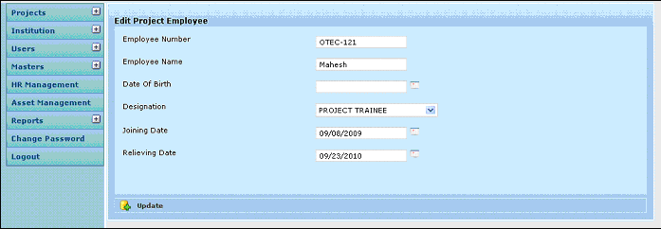

Control Description

Field /Label | Input-Control | Data Type | Remarks / Edit Check
Employee Name | Auto populated but editable Textbox | String | Required
Employee Number | Auto populated but editable Textbox | String | Required; Check for duplicates
Date of Birth | Auto populated but editable Calendar | String | Required
Joining Date | Auto populated but editable Calendar | Date | Required
Relieving Date | Auto populated but editable Calendar | Date | Optional
Designation | Auto populated but editable Listbox | String | Required;
Update | Button

Clicking on Qualification will open the Project Employee Qualification screen as shown below:

Project Employee Qualification

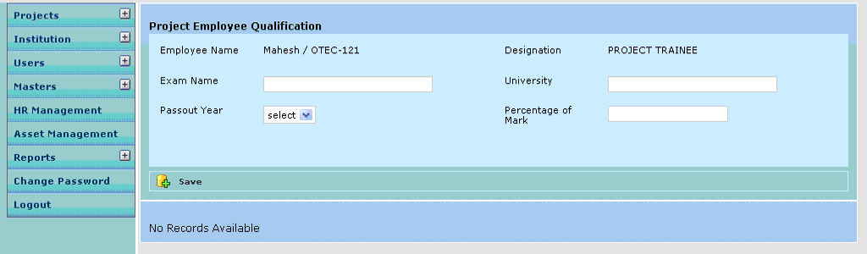

When there are no records saved for the employee, a message is displayed below – “No Records Available”

Control Description

Field /Label | Input-Control | Data Type | Remarks / Edit Check
Employee Name | Auto populated | String
Designation | Auto populated | String
Exam Name | Textbox | String | Required
University | Textbox | String | Required
Pass out Year | Listbox | String | Required
Percentage of Marks | Textbox | Number | Required
Save | Button

When there are no saved records, a message is displayed on the screen as shown above – “No records available”

Each time a record is saved, the screen is refreshed with a message – “Created Successfully” and the details y are displayed in table format as shown in the screen below:

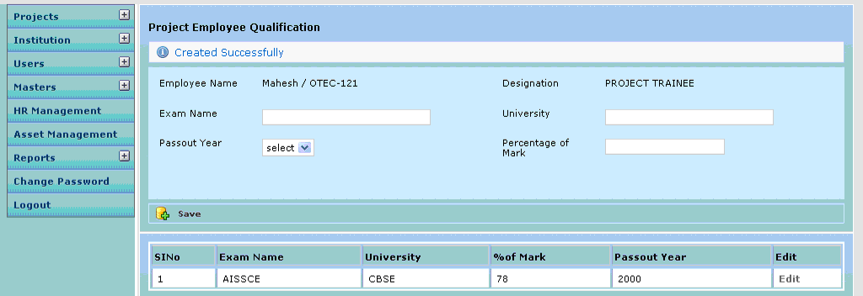

Control Description

Field /Label | Input-Control | Data Type
Sl. No | Auto generated, sequential increment for each row of record | String
Exam Name | Auto populated | String
University | Auto populated | String
Pass out Year | Auto populated | String
Percentage of Marks | Auto populated | Number
Edit | Button

Clicking on Edit opens the following screen

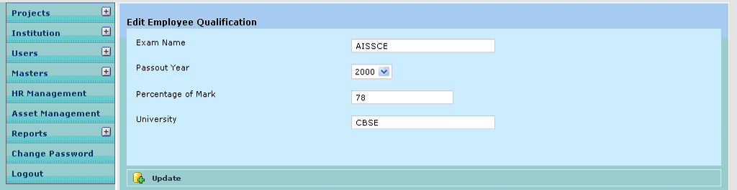

Control Description

Field /Label | Input-Control | Data Type | Remarks / Edit Check
Exam Name | Auto populated editable textbox | String | Required
University | Auto populated editable textbox | String | Required
Pass out Year | Auto populated editable textbox | String | Required
Percentage of Marks | Auto populated editable textbox | Number | Required
Update | Button

Clicking on Experience will open the Project Employee Experience screen as shown below:

Project Employee Experience
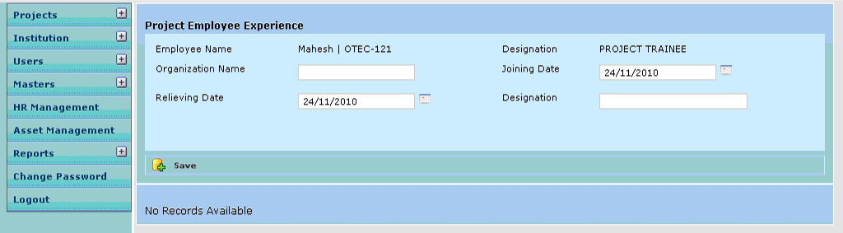

This section is optional and the institution’s policy will dictate the necessity for filling this section for experienced employees

Control Description

Field /Label | Input-Control | Data Type | Remarks / Edit Check
Employee Name | Auto populated | String
Designation | Auto populated | String
Organization | Textbox | String | Required
Joining Date | Calendar | Date | Required
Relieving Date | Calendar | Date | Required
Designation | Listbox | String | Required
Save | Button

When there are no saved records, a message is displayed on the screen as shown above – “No records available”

Each time a record is saved, the screen is refreshed with a message – “Created Successfully” and the details are displayed in table format as shown in the screen below:

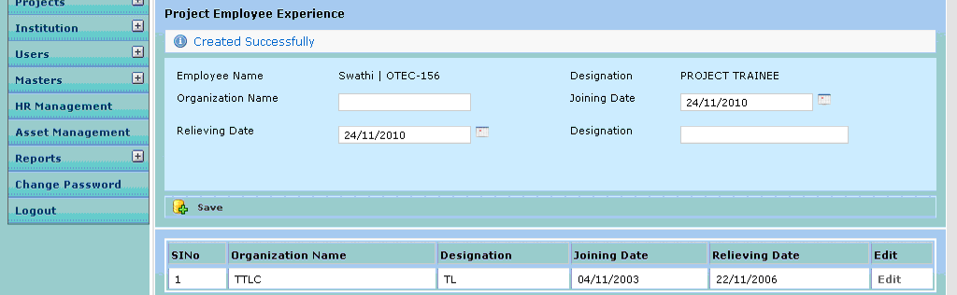

Control Description

Field /Label | Input-Control | Data Type
Sl No | Auto incremented sequential | String
Designation | Auto populated | String
Organization | Auto populated | String
Joining Date | Auto populated | Date
Relieving Date | Auto populated | Date
Edit | Button

Clicking on Edit opens the following screen
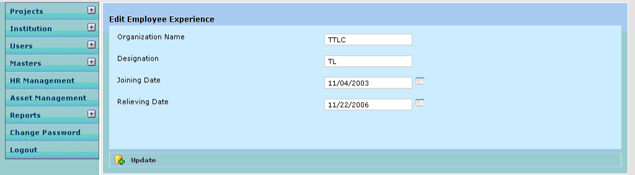

Control Description

Field /Label | Input-Control | Data Type | Remarks / Edit Check
Sl No | Auto incremented sequential | String
Designation | Auto populated editable textbox | String | Required
Organization | Auto populated editable textbox | String | Required
Joining Date | Auto populated editable calendar | Date | Required
Relieving Date | Auto populated editable calendar | Date | Required
Update | Button

Clicking on Salary will open the Project Employee Salary screen as shown below:

Project Employee Salary

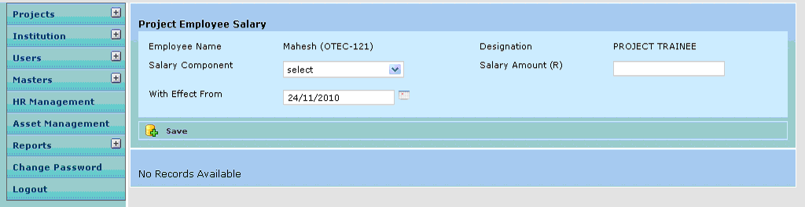

Control Description

Field /Label | Input-Control | Data Type | Remarks / Edit Check
Employee Name | Auto populated | String
Designation | Auto populated | String
Salary Component | Listbox | String | Required
Salary Amount | Textbox | Number | Required
With effect from | Calendar | Date | Required
Save | Button

When there are no saved records, a message is displayed on the screen as shown above – “No records available”

Each time a record is saved, the screen is refreshed with a message – “Created Successfully” and the details are displayed in table format as shown in the screen below:

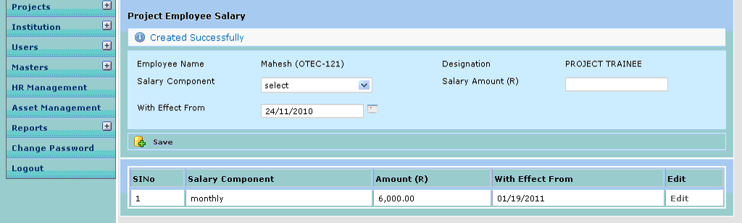

Control Description

Field /Label | Input-Control | Data Type
Sl No | Auto generated | String
Salary Component | Auto populated | String
Salary Amount | Auto populated | Number
With effect from | Auto populated | Date
Edit | Button

Clicking on Edit opens the following screen

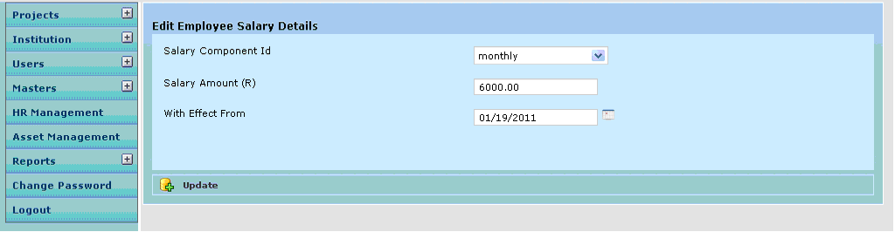

Control Description

Field /Label | Input-Control | Data Type | Remarks / Edit Check
Salary Component | Auto populated editable Listbox | String | Required
Salary Amount | Auto populated editable textbox | Number | Required
With effect from | Auto populated editable Calendar | Date | Required
Update | Button

Business Rules

Status Messages

Sl No | Status Message
1 | Created Successfully
2 | Updated Successfully
3 | Deleted Successfully
4 | The Requested Record Not Found
5 | The Record can't be deleted, Already in use
6 | The Record Already Exists
7 | Please Enter a valid email address
8 | You can not delete yourself, please login as another admin and try again
9

